**Ayesha Zubair**

**52916**

**Lab 10**

**Task 1:** Write a script that checks if a file named **data.txt** exists or not.

**Code:**

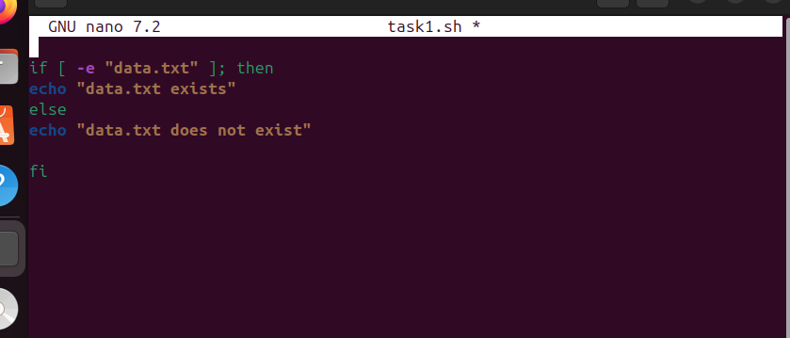

**Output:**

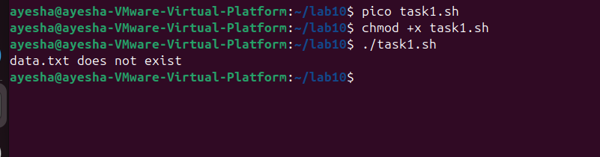

**Task 2:** Ask the user to enter a number and determine if it’s even or odd.

**Code:**

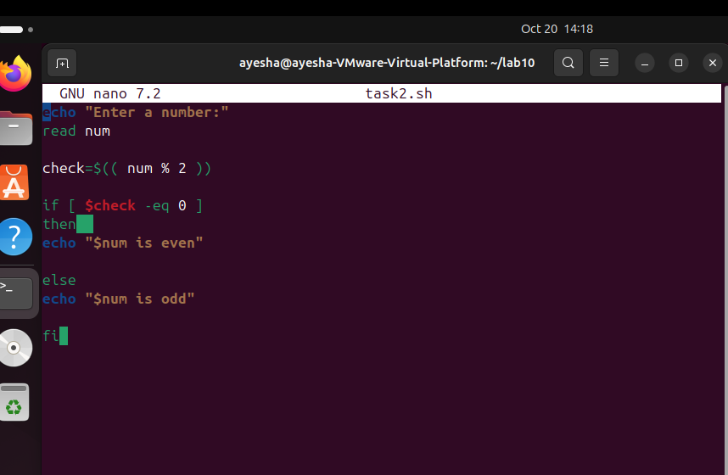

**Output:**

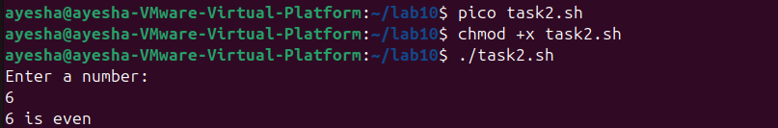

**Task 3:** Ask the user for a score (0-100) and print the corresponding grade:

* 90+: A
* 80-89: B
* 70-79: C
* 60-69: D
* Below 60: F

**Code:  
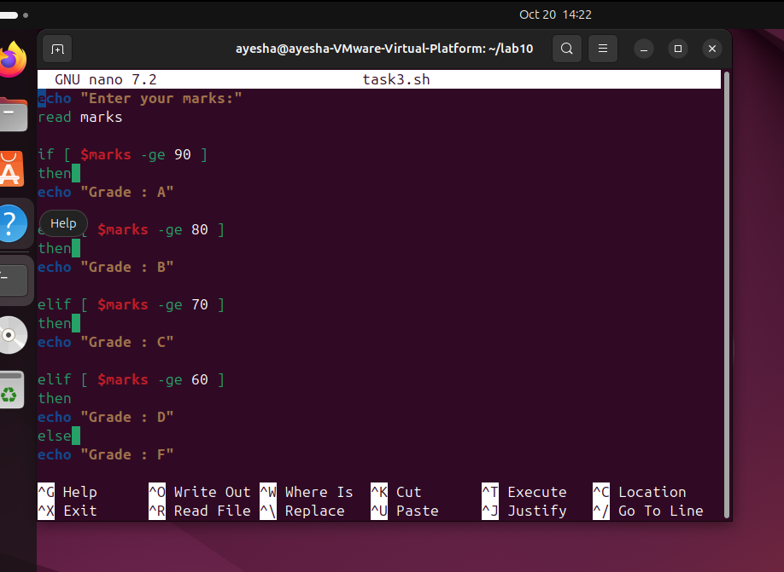**

**Output:**

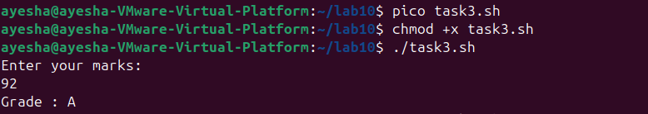

**Task 4:** Take two numbers and an operator (+, -, *, /) from the user and perform the operation.

**Code:**

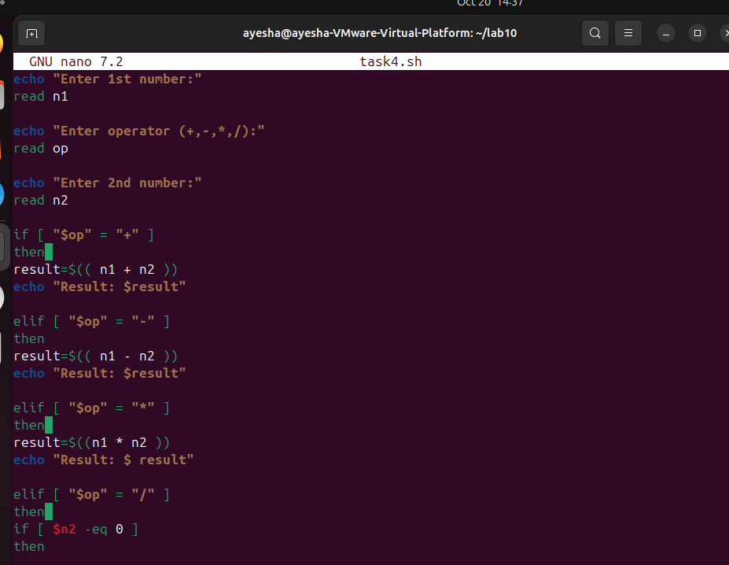

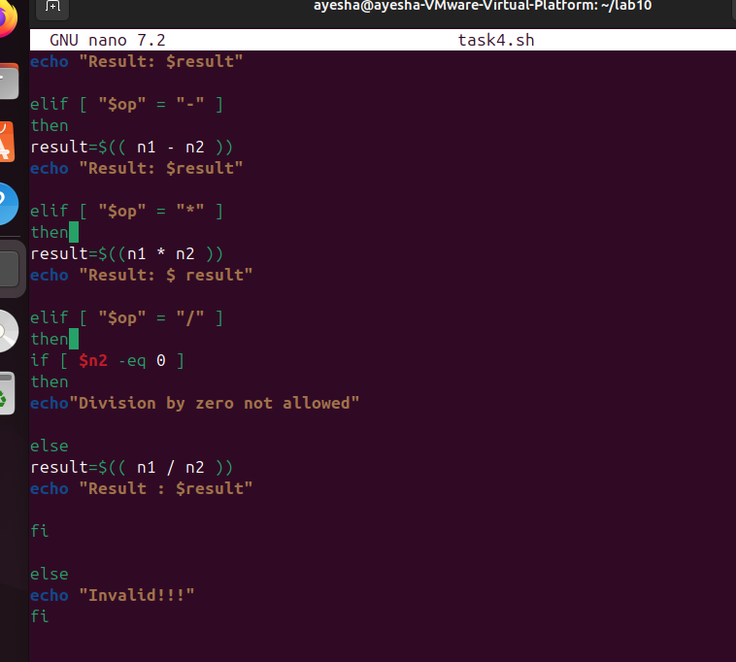

**Output:**

